Authentication Flow
LumiPixel Authentication Flow Blueprint
The authentication system should be built around one user account with role-based profiles and permissions. A person should not need separate login credentials to act as a photographer, client, or marketplace customer.
1. Core user types
Photographer
A professional who can:
- Create and manage galleries.
- Upload and organize photographs.
- Use AI tools.
- Sell photographs and services.
- Create a public photographer profile.
- Receive booking or marketplace requests.
- Manage clients, orders, payouts, and subscriptions.

Client
A person who can:
- Find their photographs using a selfie, access code, QR code, email invitation, or gallery link.
- View galleries shared with them.
- Favorite, purchase, and download photographs.
- Manage orders and saved photographs.
- Request a photographer through the marketplace.

Marketplace customer
A marketplace customer should not be a completely separate account type. Marketplace purchasing should be a capability available to every authenticated user.
That means:
- A client can hire a photographer.
- A photographer can hire another photographer.
- A person can create an account solely to request photography services.
- A marketplace customer can later become a photographer without creating another account.

Staff and administrator
Internal platform users who can:
- Review photographer verification applications.
- Moderate profiles, galleries, listings, and reports.
- Manage marketplace requests and disputes.
- Review payments and payouts.
- Suspend or restrict accounts.
- Access platform operations and analytics.

2. Recommended account architecture
Use a custom Django user model from the beginning.
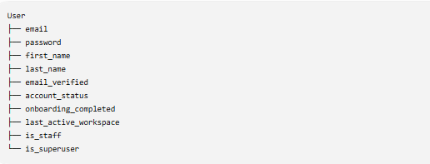
Profiles and capabilities should be connected to the user:
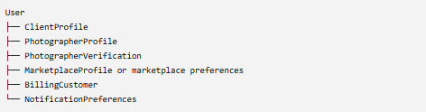
A user may have:
- Only a client profile.
- Only a photographer profile.
- Both client and photographer profiles.
- Marketplace access with either profile.
- Staff permissions in addition to normal account access.

Important design decision
Do not rely on a single field such as:
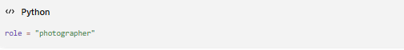
That becomes restrictive when a photographer also wants to purchase images or hire another photographer.
A better structure is:
combined with profile and capability checks:
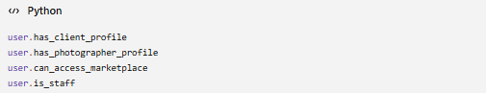
The primary_role determines the default dashboard. It should not determine everything the person is allowed to do.

3. What happens after someone clicks “Start Free”?
The homepage button should first determine the visitor’s intent.
Start Free selection page
Route:
The visitor sees three options:
I’m a Photographer
Supporting text:
Upload, organize, deliver, sell, and intelligently manage your photographs.
Button:
I’m Looking for My Photos
Supporting text:
Use a selfie, gallery code, invitation, or event link to securely find your photographs.
Button:
I Need a Photographer
Supporting text:
Tell us what you need and connect with photographers who match your request.
Button:
The selected intent should be stored temporarily:
After that, the visitor goes to the appropriate account creation or guest-entry flow.

4. Photographer registration flow
Step 1: Create the account
Route:
Initial fields:
- First name.
- Last name.
- Email address.
- Password.
- Password confirmation.
- Agreement to Terms of Service.
- Agreement to Privacy Policy.
Do not ask for every business detail on the registration page. A long registration form will increase abandonment.
After submission:
- Create the user account.
- Create an incomplete PhotographerProfile.
- Send email verification.
- Sign the user in with limited access.
- Redirect to email confirmation.
Route:
Step 2: Verify email address
The user receives:
- A verification link.
- Optionally, a six-digit verification code.
After verification:
Redirect:
Step 3: Photographer onboarding
The onboarding process should be divided into manageable steps.
Business information
- Business or studio name.
- Photographer display name.
- Phone number.
- City and state.
- Service area.
- Website, if available.
Photography specialties
Examples:
- Portrait.
- Wedding.
- Event.
- Sports.
- Street.
- Graduation.
- Family.
- Commercial.
- Real estate.
- Fashion.
- Product.
- Corporate.
A photographer may select multiple specialties.
Public profile
- Profile photograph or logo.
- Cover image.
- Biography.
- Years of experience.
- Starting price or pricing visibility.
- Social links.
- Whether the photographer accepts marketplace requests.
Verification information
- Legal name.
- Business name, if applicable.
- Identity document.
- Business registration, if applicable.
- Portfolio or website.
- Professional references, if required.
- Agreement to photographer standards.
Not all verification items need to be mandatory for the MVP. Identity, contact information, and portfolio review may be sufficient initially.
Payment and payout setup
This can be skipped during initial onboarding.
The photographer can enter the dashboard before completing payouts, but cannot receive payouts until Stripe Connect or the selected payout provider is configured.

5. Photographer verification lifecycle
Photographer verification should be separate from email verification.
A photographer can have one of these verification statuses:
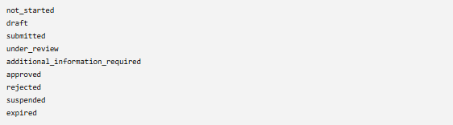
Recommended behavior
Not started or draft
The photographer can:
- Access the photographer dashboard.
- Create drafts.
- Upload test photographs.
- Configure account settings.
- Explore platform tools.
The photographer cannot:
- Display a verified badge.
- Publish a marketplace listing.
- Accept paid marketplace jobs.
- Receive payouts.
- Publicly advertise as verified.

Submitted or under review
The photographer can continue setting up the account but cannot edit verification-sensitive fields without withdrawing or restarting the review.
Display:
Your verification application is currently under review.
Additional information required
The photographer receives:
- An email.
- An in-app notification.
- A verification dashboard message.
- A list of missing or rejected items.

Approved
The system records:
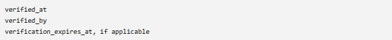
The photographer receives:
- Verified badge.
- Marketplace publishing permission.
- Paid booking eligibility.
- Payout eligibility, provided payment onboarding is complete.
- Higher trust placement in search results.
Rejected
A rejection should include:
- A reason category.
- An internal staff note.
- A user-facing explanation.
- Whether reapplication is allowed.
- The date when reapplication becomes available.

Suspended
Suspension is different from rejection. It applies when a previously approved photographer loses marketplace or platform privileges.

6. Client account flow
Clients should encounter as little friction as possible.
Entry paths
A client might enter through:
- Homepage.
- Photographer’s gallery link.
- QR code.
- Event code.
- Email invitation.
- Selfie search.
- Marketplace request page.
- Checkout.
The platform should preserve the client’s original destination through authentication.
Example:
After authentication, the client returns to that gallery rather than being forced into the general dashboard.
Client registration fields
Initially require only:
- First name.
- Email address.
- Password.
- Terms and privacy acceptance.
Phone number should be optional unless required for a booking.
After account creation
The client sees one of two experiences.

Client came from a particular gallery or invitation
Redirect back to:
- Shared gallery.
- Selfie search result.
- Event photo page.
- Checkout.
- Photographer booking page.
Client registered without a specific destination
Redirect to:
The dashboard should initially show:
- Find My Photos.
- Galleries shared with me.
- Recent photographs.
- Favorites.
- Orders and downloads.
- Photographer requests.
- Account settings.
For a brand-new client, empty states should provide clear actions:
You do not have any shared galleries yet.
Buttons:
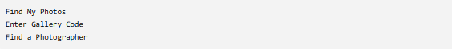

7. “Find My Photos” authentication behavior
Clients should be allowed to begin searching before being forced to create an account.
Recommended flow
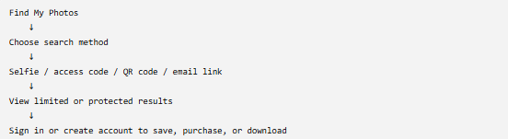
Guest users may be allowed to:
- Enter a gallery access code.
- Upload a selfie for matching.
- See watermarked thumbnails.
- See how many potential matches were found.

Authentication should be required to:
- Save facial-search results.
- Access private full-resolution previews.
- Favorite photographs.
- Purchase photographs.
- Download photographs.
- Reopen search history.
- Manage consent or request deletion.
This approach lets the product demonstrate value before asking for registration.

Temporary search preservation
Before authentication, save the search session using a signed temporary token.
After login or registration:
- Associate the temporary search with the new user.
- Remove or expire the guest token.
- Return the user to the result page.

8. Marketplace authentication flow
Marketplace access should begin with the user’s intent, not a mandatory account-type selection.
Marketplace request flow
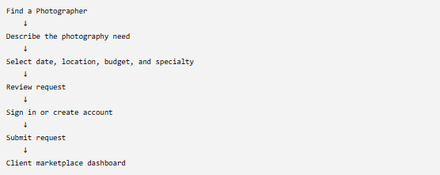
Allow users to build the request before registration. Require authentication only when they are ready to submit it.
This prevents a lengthy signup wall before the user experiences the service.
Marketplace user capabilities
An authenticated client can:
- Submit a photography request.
- Save photographers.
- Invite photographers.
- Receive proposals.
- Compare quotes.
- Message photographers.
- Accept a proposal.
- Pay deposits.
- Manage bookings.
- Review completed work.
An approved photographer can:
- Create a marketplace listing.
- Receive matched opportunities.
- Send proposals.
- Accept direct invitations.
- Manage bookings.
- Receive payments.
- Review clients after completed work, if the platform supports mutual reviews.
An unverified photographer may browse marketplace opportunities but should not submit proposals or receive payments.

9. Login redirect rules
Login redirection should follow a clear order of precedence.
Redirect priority
1. Explicit next destination
When login was triggered from a protected page:
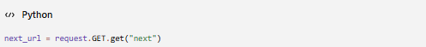
After login, return the user there, provided it is a safe internal URL.
2. Incomplete mandatory action
Examples:
- Email not verified.
- Account suspended.
- Required password reset.
- Required consent update.
- Photographer onboarding incomplete.
Redirect to the required action before any dashboard.
3. User’s last active workspace
If the user has both client and photographer profiles, restore the workspace they used most recently.
Examples:
4. Primary role dashboard
User condition | Default destination
Photographer only | /photographer/dashboard/
Client only | /client/dashboard/
Photographer and client | Last active workspace
Marketplace-only client | /marketplace/dashboard/ or client marketplace section
Staff | /operations/
Superuser | /admin/ or /operations/
New photographer | /onboarding/photographer/
New client | /client/dashboard/
Email not verified | /verify-email/

Workspace switcher
Users with multiple profiles should see a workspace switcher in the account menu:
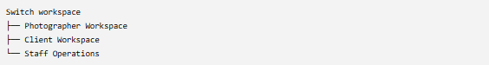
Switching should update:
The user remains logged in; only the interface and permissions context change.

10. Role permission matrix
Feature | Guest | Client | Photographer draft | Verified photographer | Staff | Admin
View public pages | Yes | Yes | Yes | Yes | Yes | Yes
Search using gallery code | Limited | Yes | Yes | Yes | Yes | Yes
Upload selfie for search | Limited | Yes | Yes | Yes | Yes | Yes
Save search results | No | Yes | Yes | Yes | Yes | Yes
Purchase photographs | No | Yes | Yes | Yes | Yes | Yes
Download purchased photos | No | Yes | Yes | Yes | Yes | Yes
Create galleries | No | No | Yes | Yes | Optional | Yes
Publish galleries | No | No | Limited | Yes | Optional | Yes
Use AI workspace | No | No | Plan-based | Plan-based | Optional | Yes
Create public photographer profile | No | No | Draft | Yes | Optional | Yes
Publish marketplace listing | No | No | No | Yes | Review | Yes
Submit marketplace request | No | Yes | Yes | Yes | Yes | Yes
Send marketplace proposals | No | No | No | Yes | No | Yes
Receive payouts | No | No | No | Yes, after payout setup | No | Manage
Review verification | No | No | No | No | Yes | Yes
Suspend accounts | No | No | No | No | Permission-based | Yes
Manage platform settings | No | No | No | No | Limited | Yes
Permissions should be checked on the server. Hiding a button in HTML is not security.

11. Account status controls
The main user account should have statuses such as:
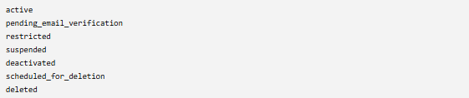
These statuses control overall login and platform access.
Photographer verification status should remain separate:
This allows the photographer to use permitted parts of the platform while verification is pending.

12. Authentication pages required
Shared pages
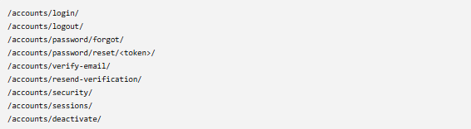
Signup pages
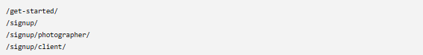
The marketplace signup can use the client registration process:

Photographer onboarding


Client onboarding
Client onboarding should be lightweight:
Potential fields:
- Display name.
- Profile image, optional.
- Notification preferences.
- Location, optional.
- Photography interests, optional.
Most clients should be able to skip this.

13. Recommended Django application structure
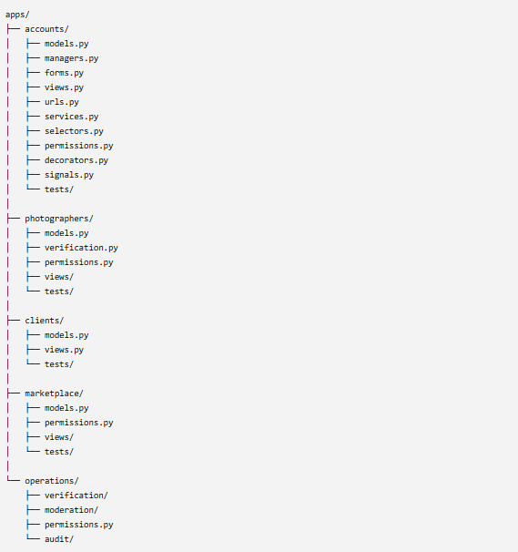

14. Authentication flow diagram
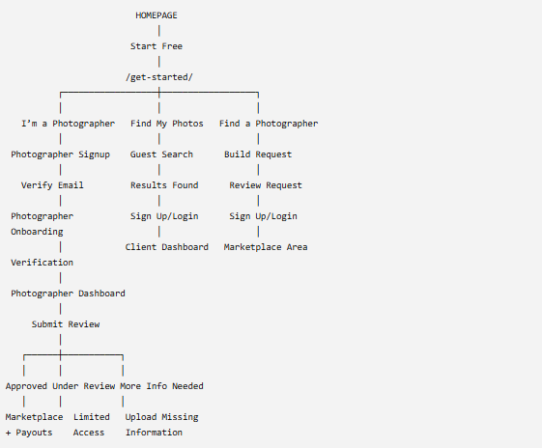
15. Critical business rules
- Email must be unique across the platform. One email represents one LumiPixel account.
- A photographer is also allowed to behave as a client. Do not block photographers from buying photos or hiring photographers.
- Marketplace customer is a capability, not a permanent role.
- Email verification and photographer verification are different processes.
- Unverified photographers can explore and prepare their workspace but cannot represent themselves as platform-verified.
- Preserve the user’s original destination through login and registration.
- Never trust a role passed from the browser. Permissions must be loaded from the authenticated user on the server.
- Every administrative action should create an audit record.
- Sensitive verification documents should not be stored in the public media directory.
- Users should be able to switch workspaces without logging out.

